

**TityTots**

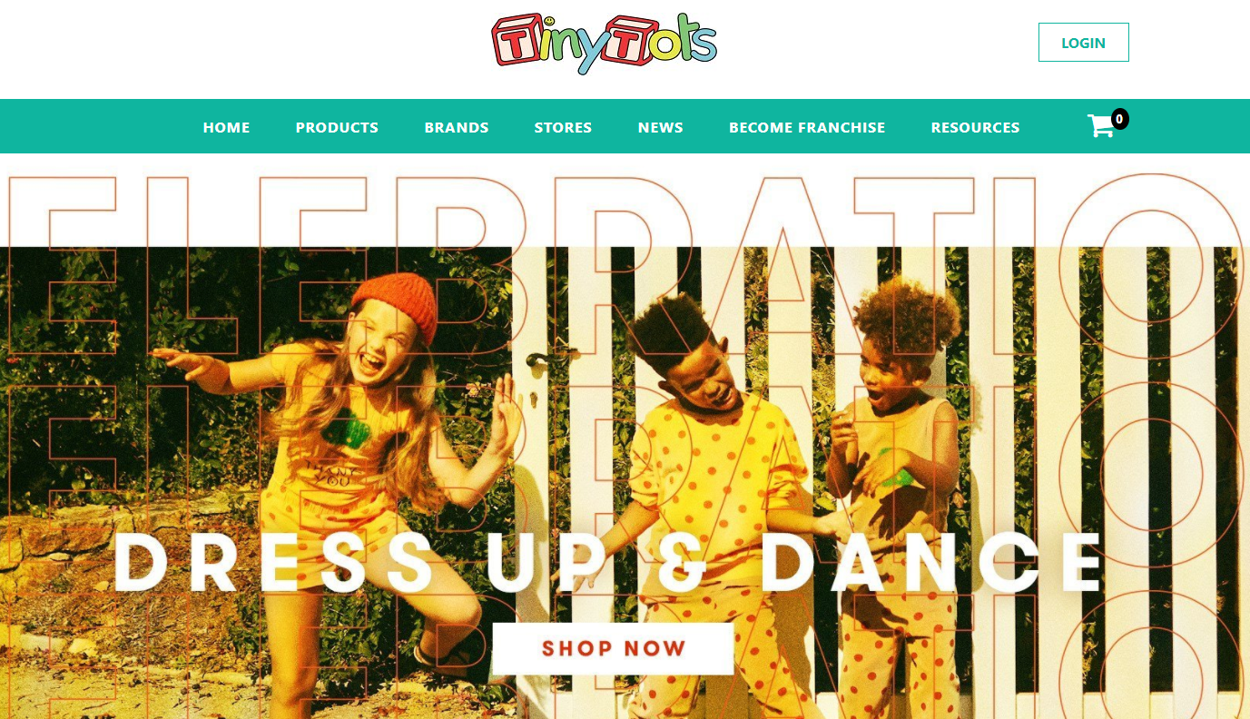

**Class: C2007L**

**Author**

1. Nong Quoc Chien

2. Nguyen Quoc Phuong

3. Nguyen Quang Huy

4. Vu Viet Anh

**Mentor: Luc Van**

*Ha Noi, summer 2021*

***Protect the eProject***

**INDEX**

**1.** **Acknowledgements** 3

**2.** **eProject Synopsis** 3

**3.** **eProject Analysis** 3

**4.** **eProject Design** 3

**4.1.** **DFD’s** 3

**4.3.** **Process Diagrams** 3

**4.4.** **Database Design** 3

**5.** **Screen Shot’s** 3

**6.** **Source Code with Comments** 3

**7.** **User Guide** 3

**8.** **Developer’s Guide** 3

1. **Acknowledgements**The 21st century is witnessing the strong development of the Information Technology industry. Information Technology (IT) has been changing the world rapidly and gradually pulls the knowledge base and gradually pulls human knowledge closer together. It is thanks to the development of the worldwide Website system. Nowadays, Website has played an important role for us people from entertainment to advertising, e-commerce... E-commerce website will gradually replace the old business methods in businesses by advantages that it brings such as: faster, more convenient, more efficient and not limited in space and time.  
     
   Stemming from those actual needs, our team decided to build a Website to serve the needs of children in order to create a management system for a small shop.
2. **eProject Synopsis  
   Target project:**- Building Website shopping tinytots

* Researching PHP, JavaScript… Website Development Technology
* Optimize sales management process research
* Report and summary results

1. **eProject Analysis  
   Technology used:**

* **HTML5/CSS:** HTML5 and CSS3 represent numerous opportunities in web development for businesses that develop and deploy online content and web applications. Overall, by using both of these tools in your businesses' web development you can optimise your users' web experience, provide a solid foundation for your SEO and content marketing strategy and significantly reduce your cross-platform web development and support costs whilst increasing your reach and optimising web experience.
* **Bootstrap:** The primary benefit of using Bootstrap as a CSS framework is to encourage consistency across internal tools. Rather surprisingly, until recently there were barely any processes in place to share common design patterns and assets. Straight out of the box Bootstrap supports the latest versions of Google Chrome, Firefox, Internet Explorer, Opera, and Safari. It even provides support as far back as Internet Explorer 8, meaning Bootstrap will offer you wider accessibility right from the start.
* **JavaScript:** JavaScript is a scripting language that’s inserted directly in the HTML of a page. It’s the only programming language of this kind that can be understood by web browsers. Browsers can read Javascript, interpret it and then run the program, creating powerful client-side experiences.
* **Ajax:** AJAX is needed to make calls to the server using JavaScript. You cannot execute something in a back-end language alone without reloading the page. AJAX helps you to do that. So when you start typing something in Google, JavaScript detects each 'button press' event and it makes AJAX calls after each such event to a back-end file which in-turn sends back the results.
* **PHP:** PHP is mainly focused on server-side scripting, so you can do anything any other CGI program can do, such as collect form data, generate dynamic page content, or send and receive cookies. But PHP can do much more. There are three main areas where PHP scripts are used. Server-side scripting

1. **eProject Design**
   1. **DFD’s**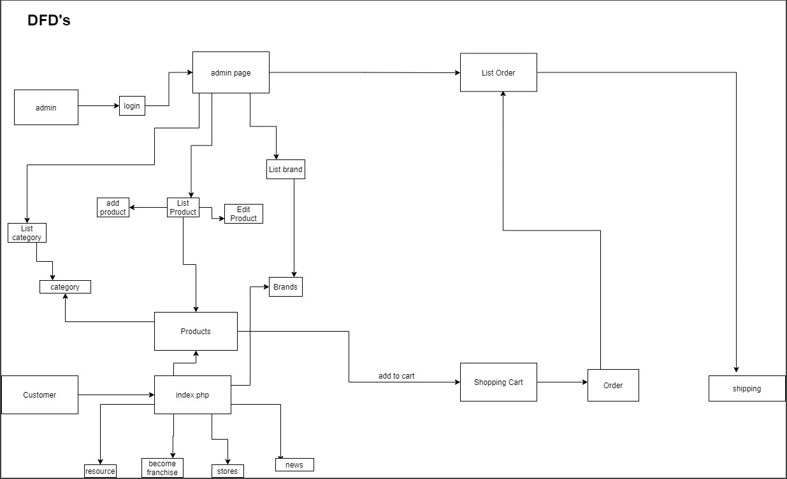
   2. **Process Diagrams**

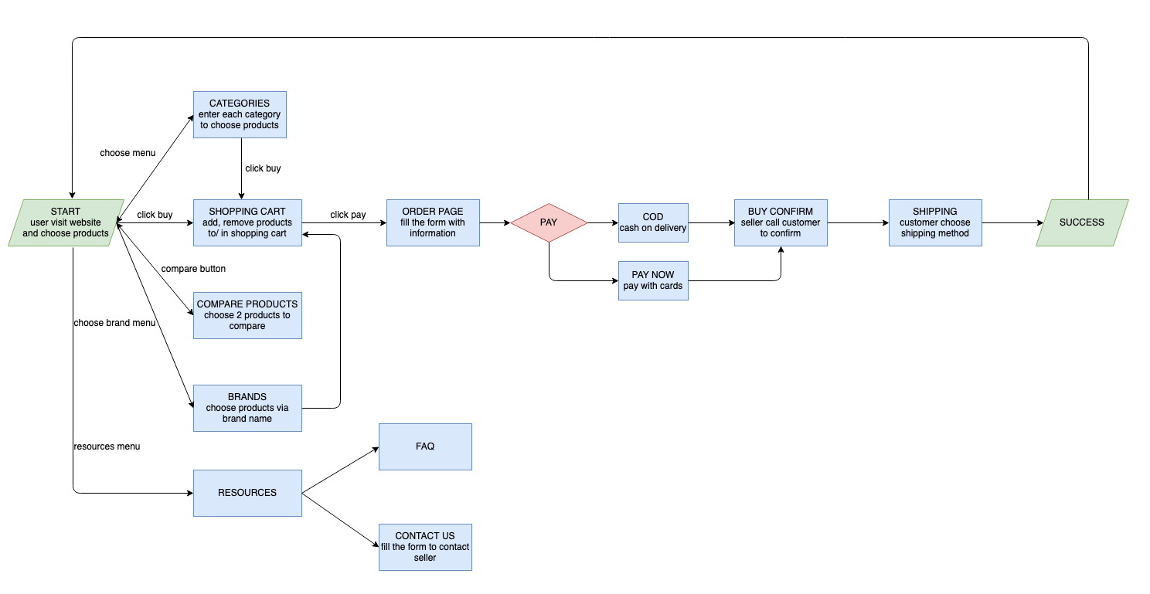

* 1. **Database Design**

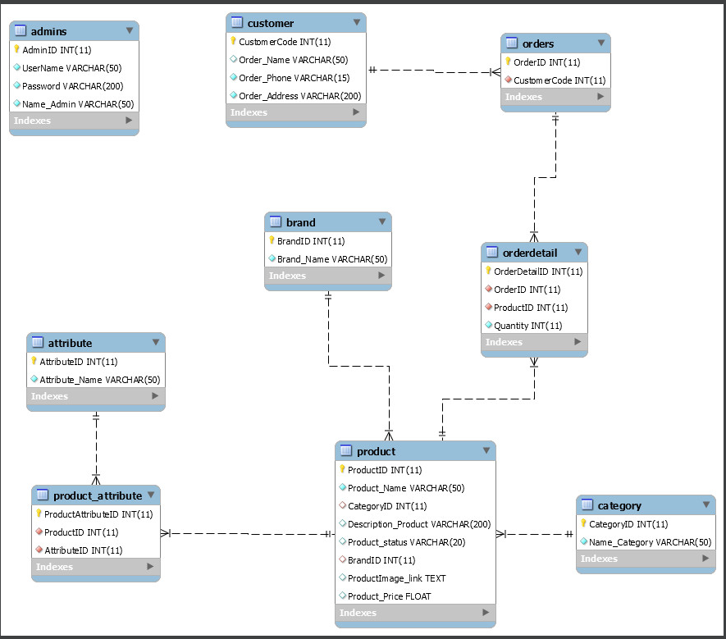

1. **Screen Shot’s**

* **Homepage**

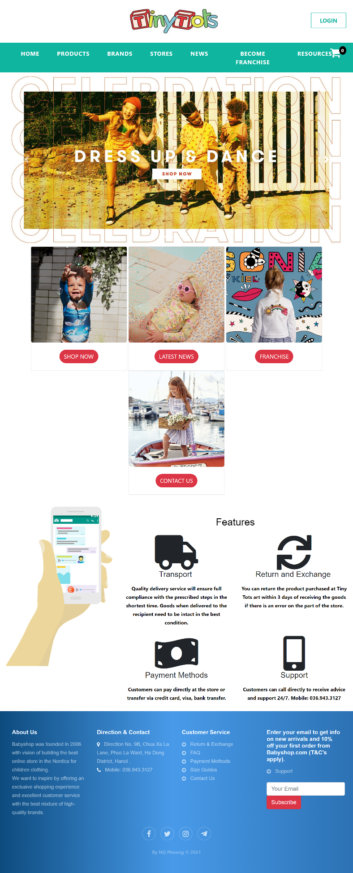

* **Product  
  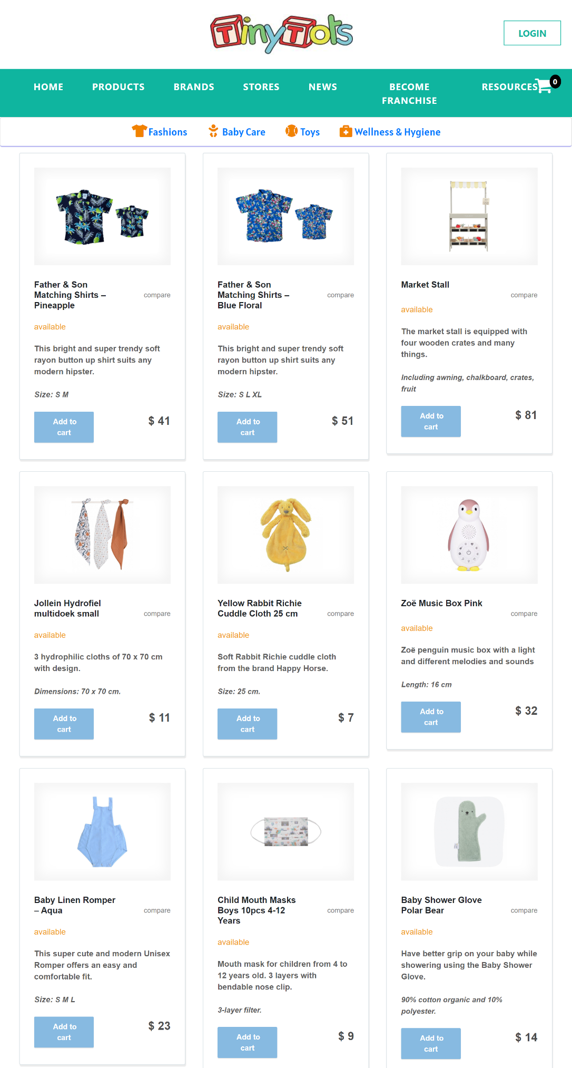**
* **Store  
  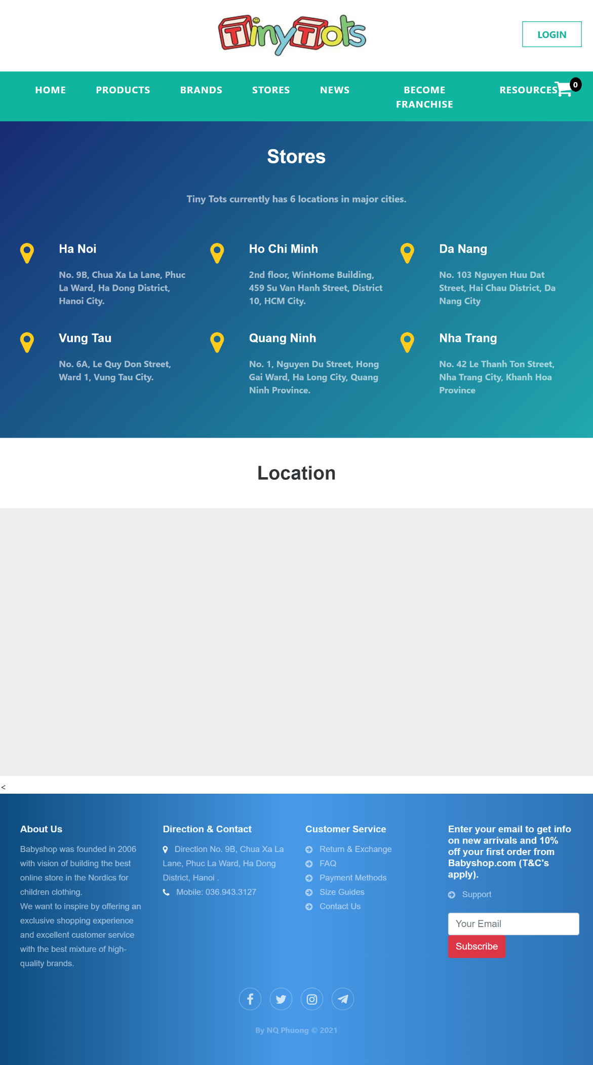**
* **Franchies  
  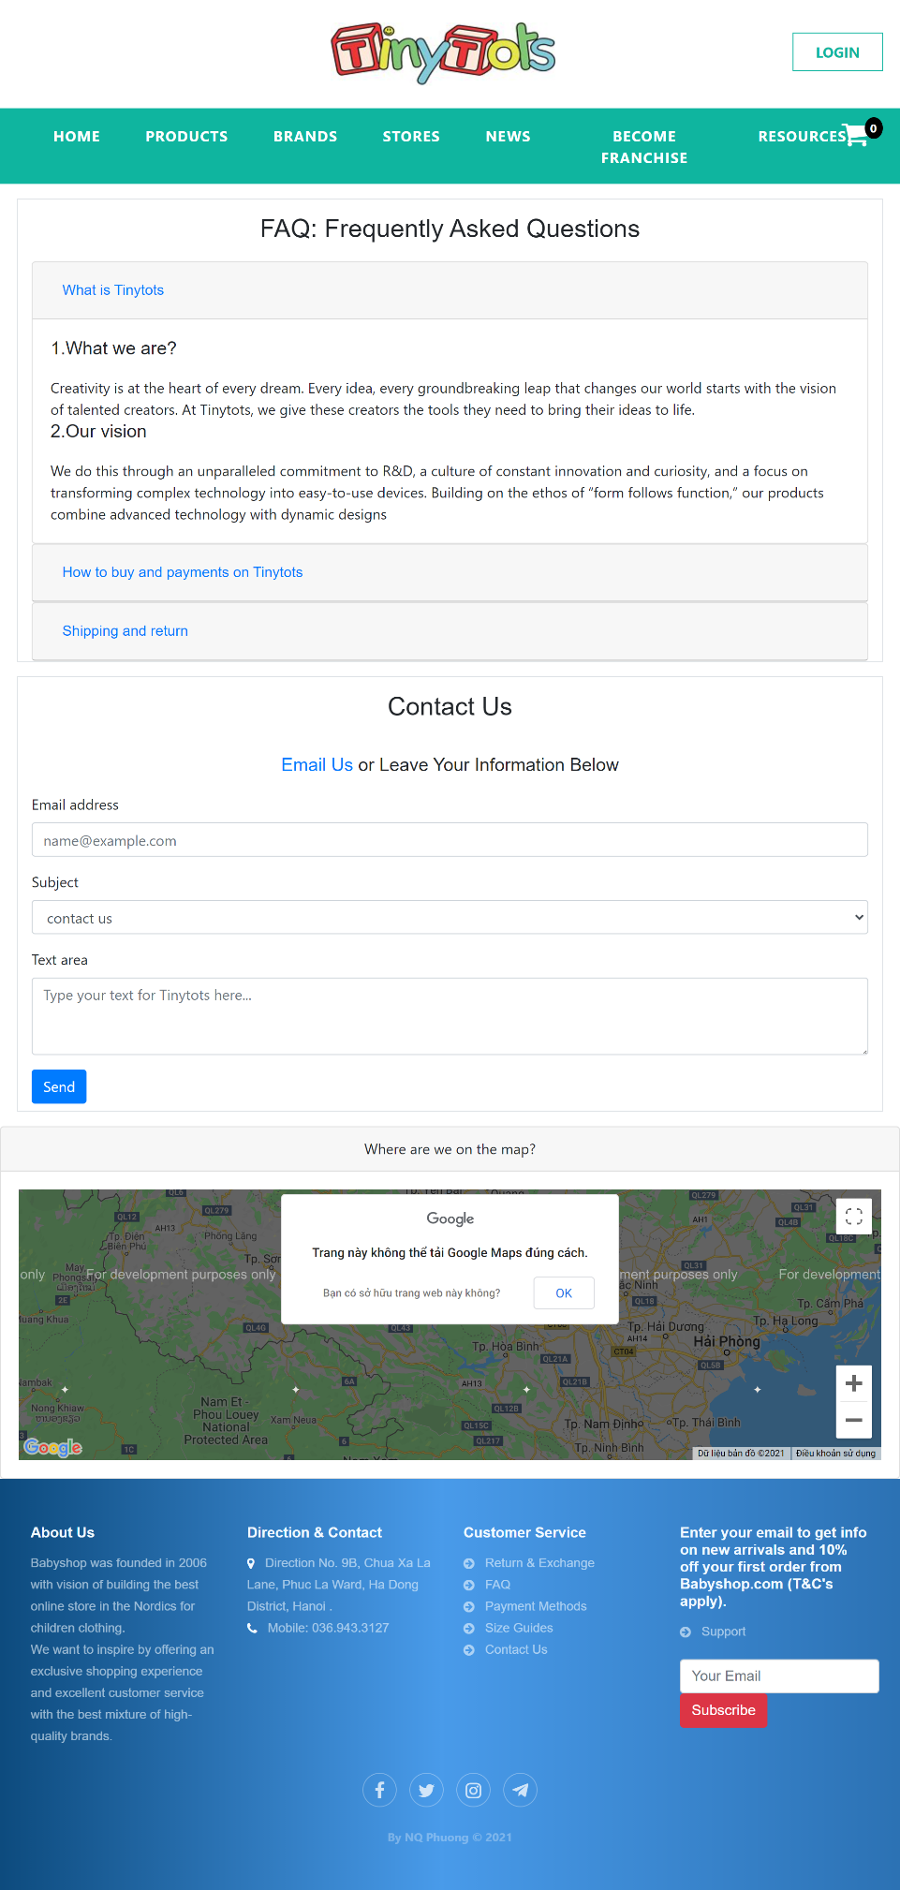**
* **Resource  
  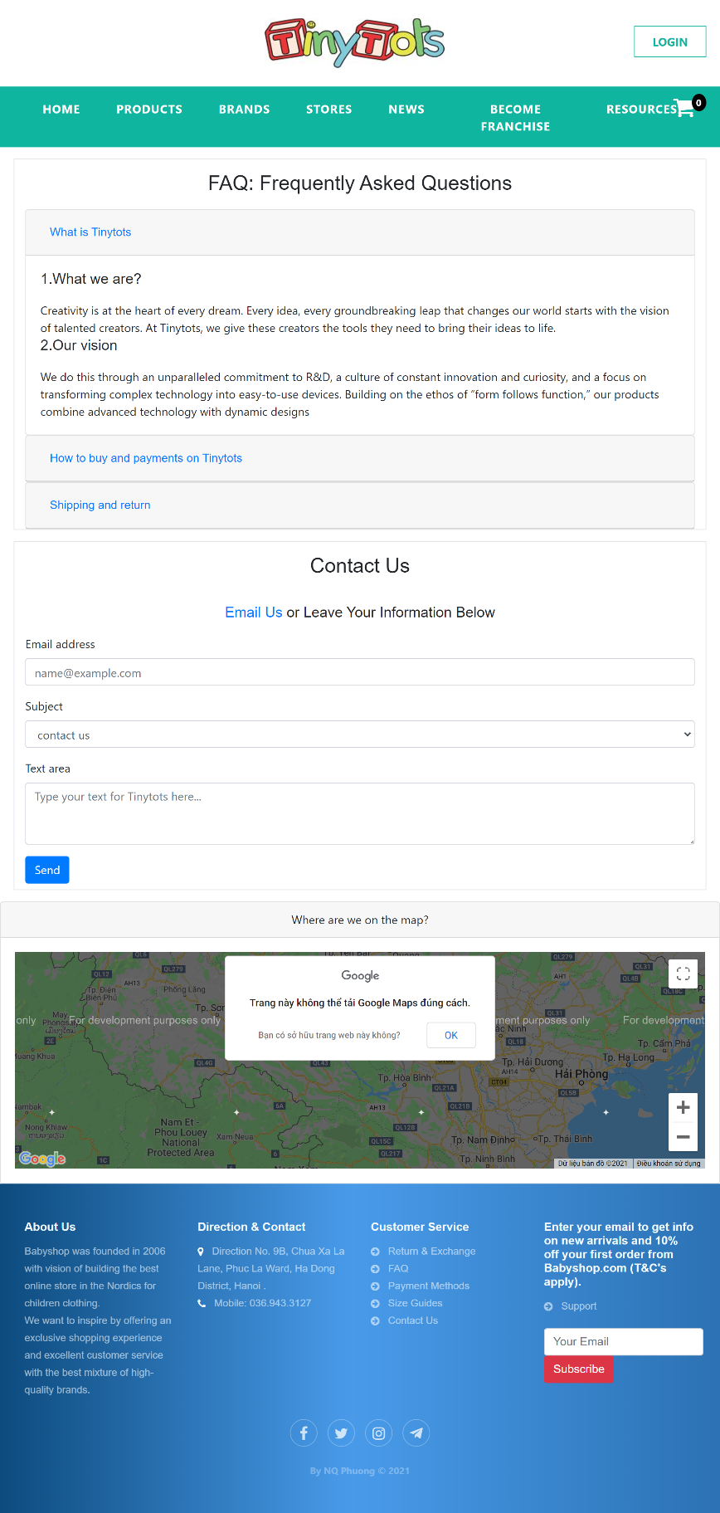**

1. **User Guide  
   Add to cart:** Add the product you want to buy to the cart

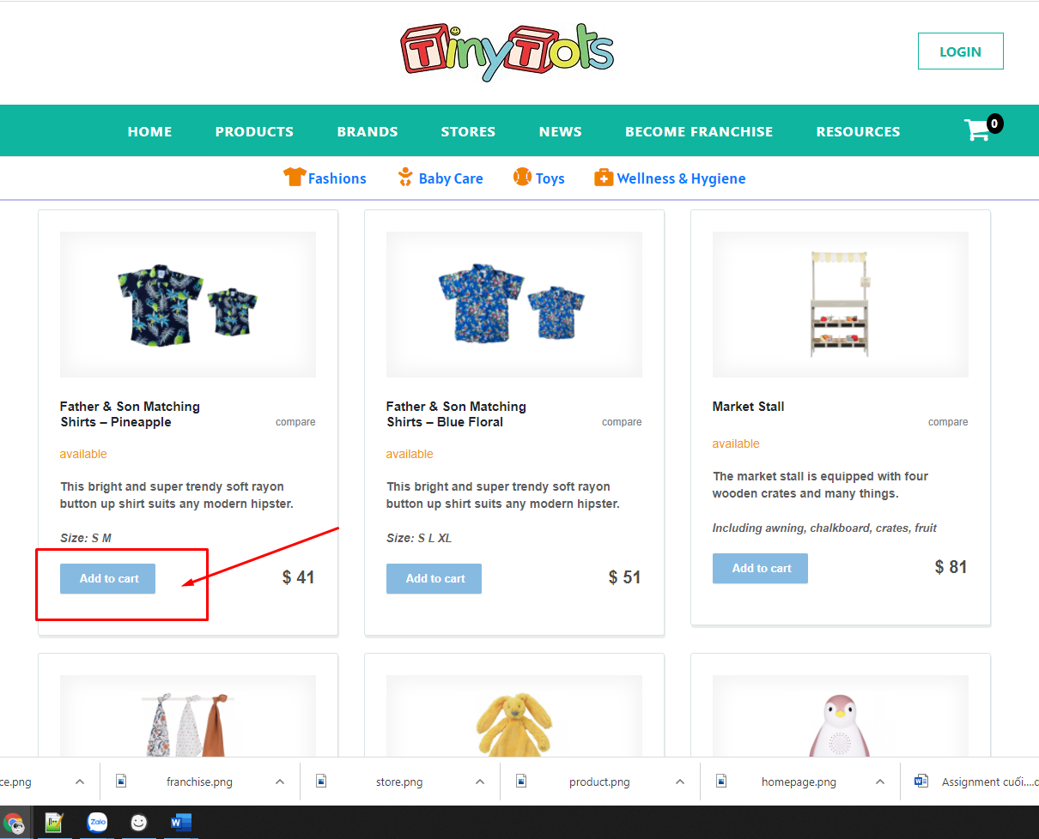

**The product has been added to cart**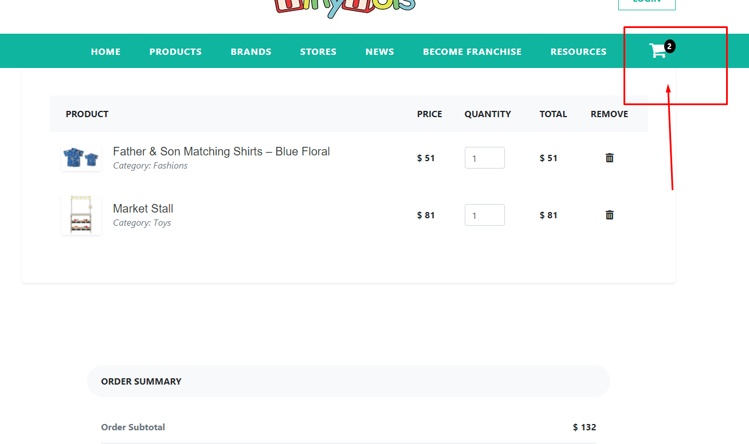

**Start Paying**

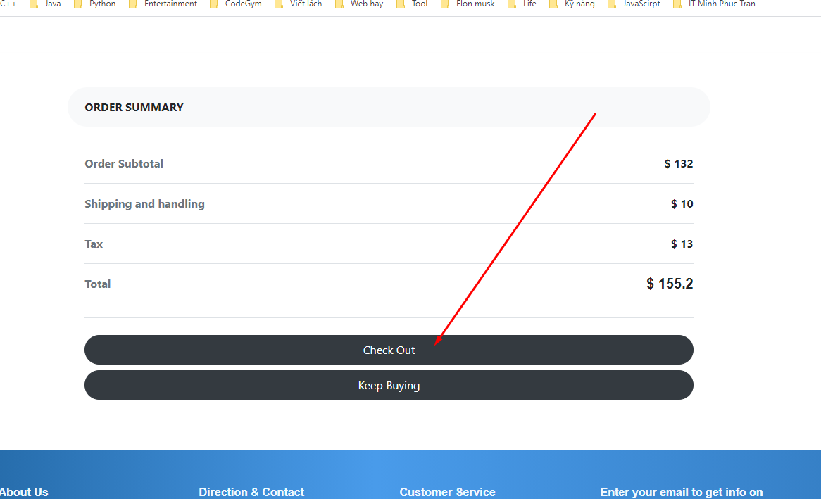

**Chose method paying**

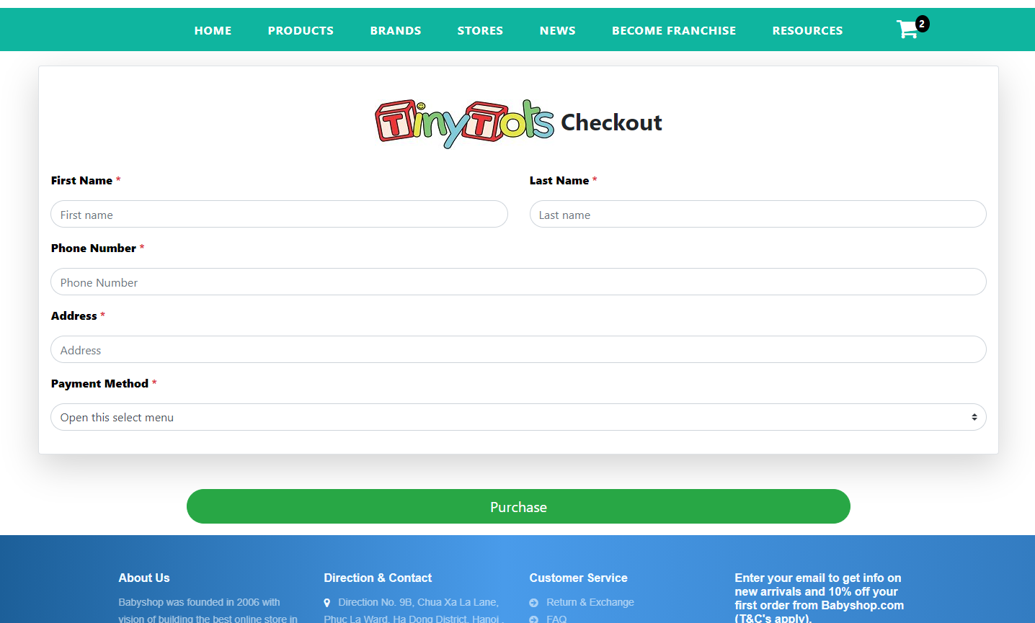 **Becamefranchise**

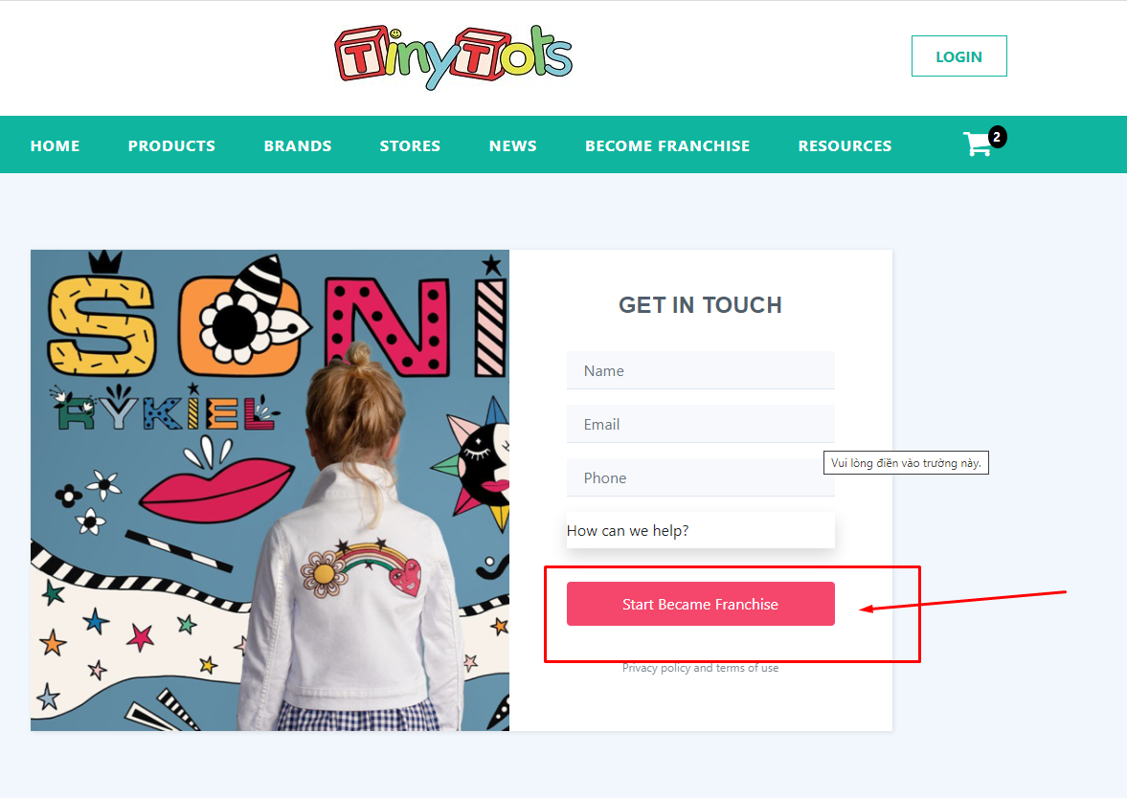

1. **Developer’s Guide**

**Go to the admin page**

To login to the admin page, click on the login button on the menu:

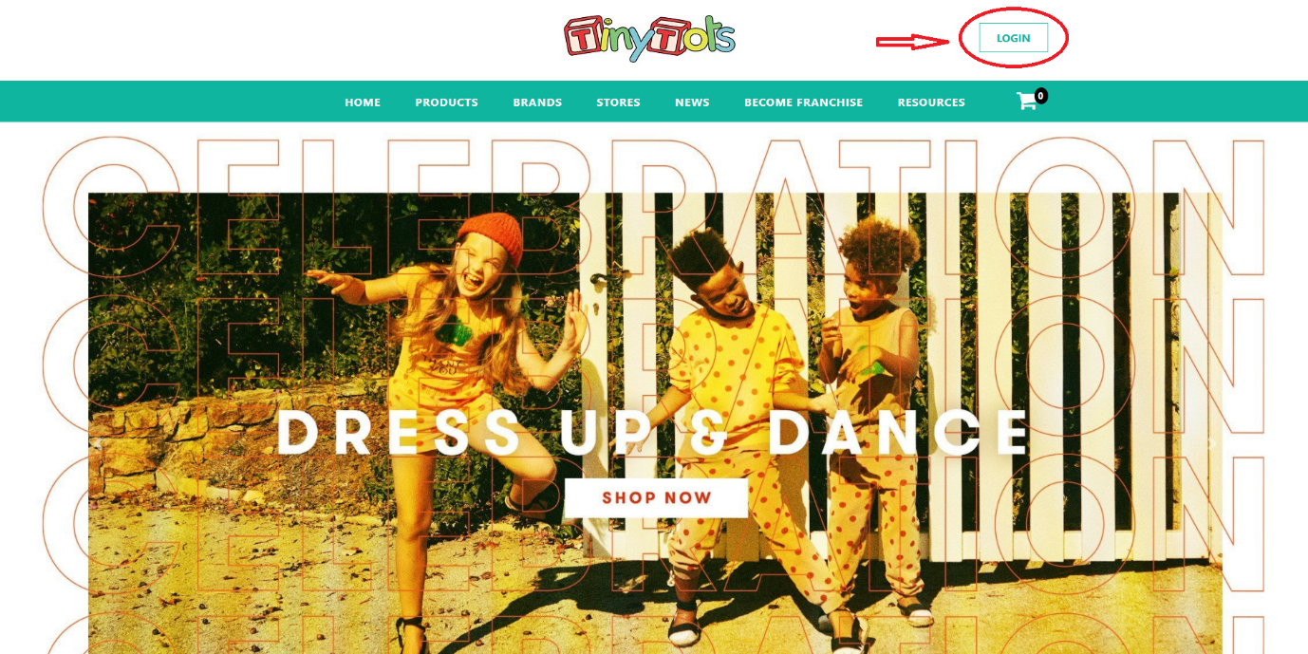

**Login as administrator**

After entering the admin page, the administrator needs to log in with his account

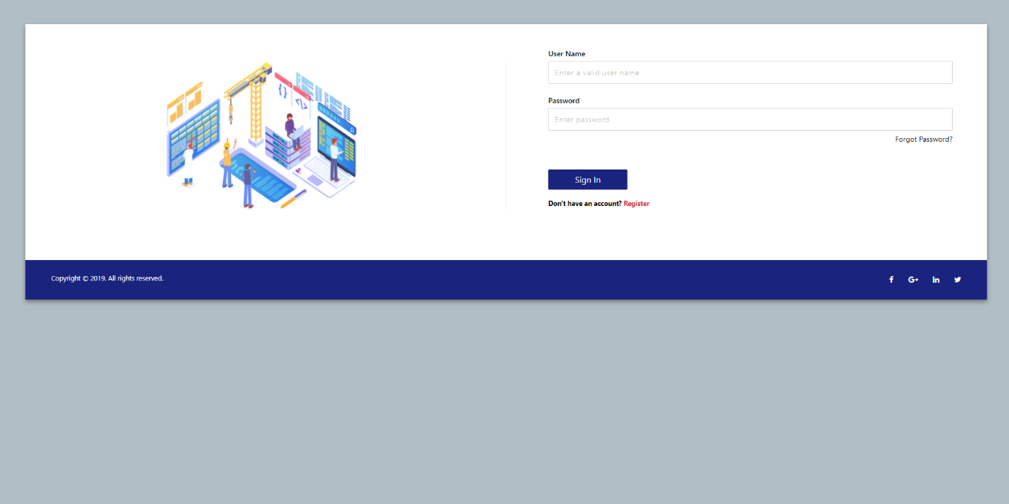

After logging in, you will be redirected to the admin page:

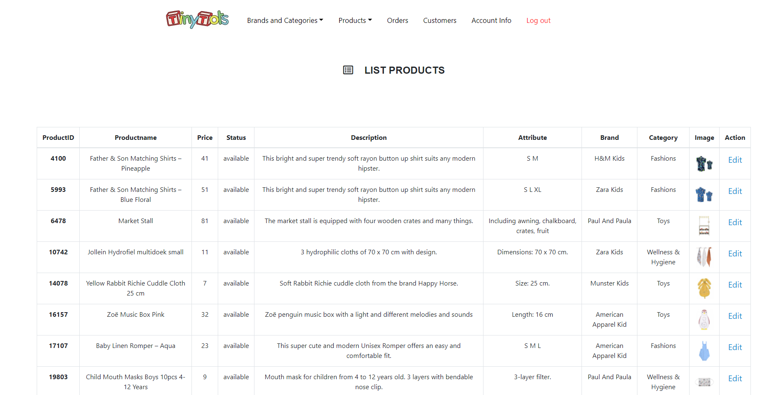

Here, admin can add, edit and delete products, add and edit brands and categories, view customer information and orders.

Add brands and categories:

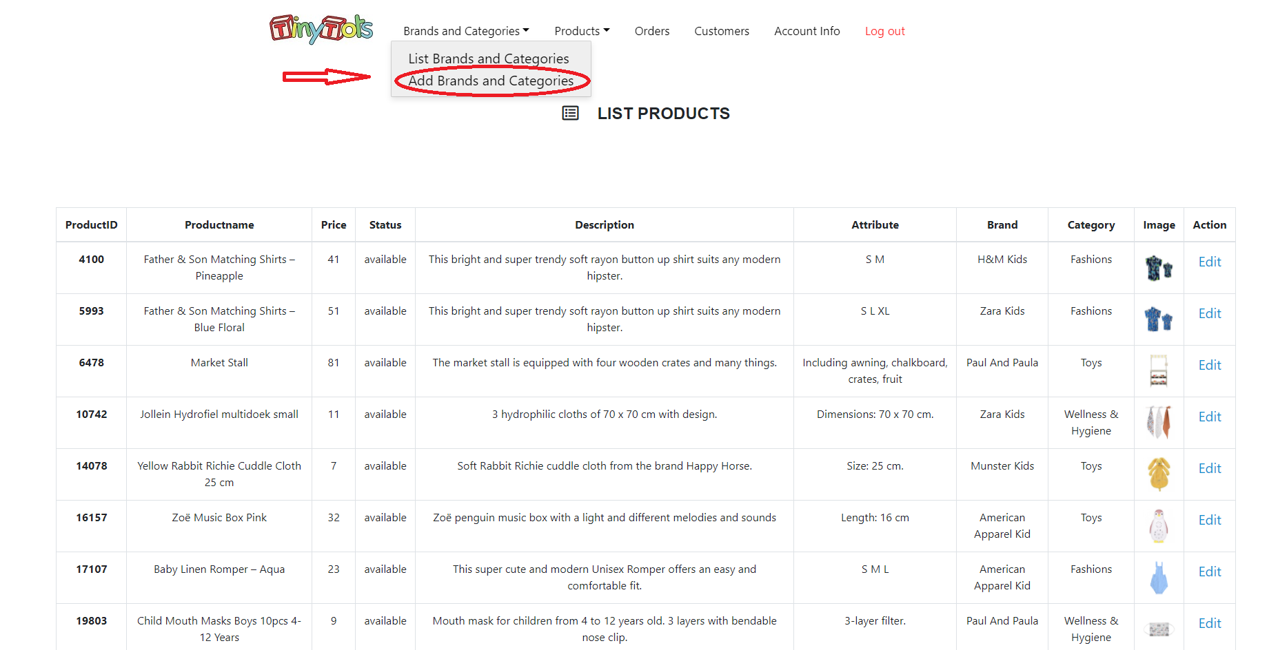

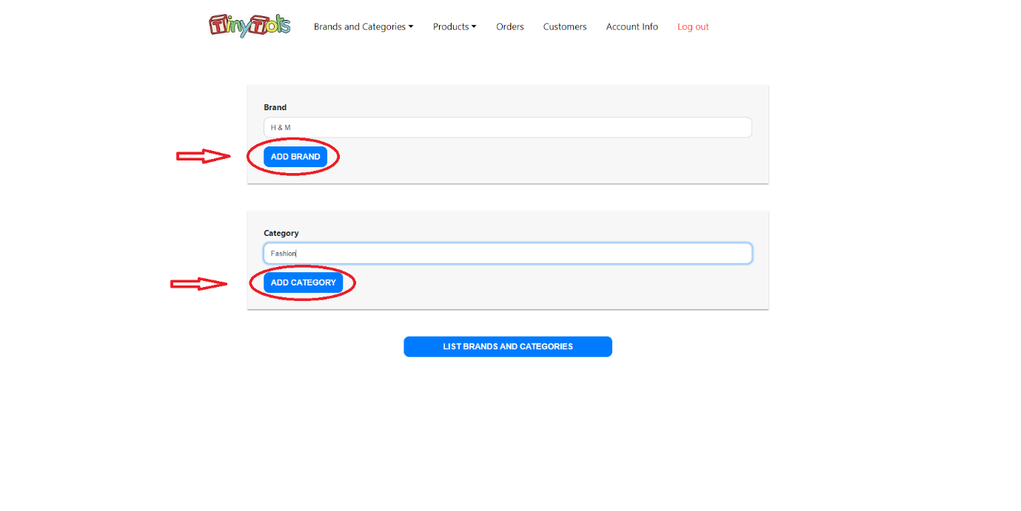

Edit, delete brands and categories

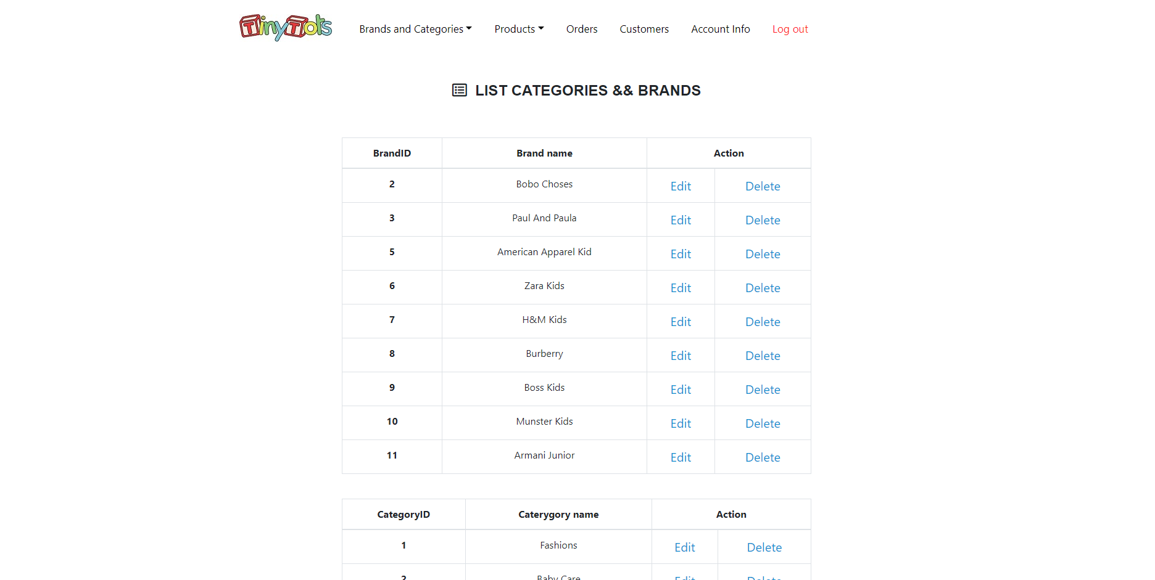

**Add Products:**

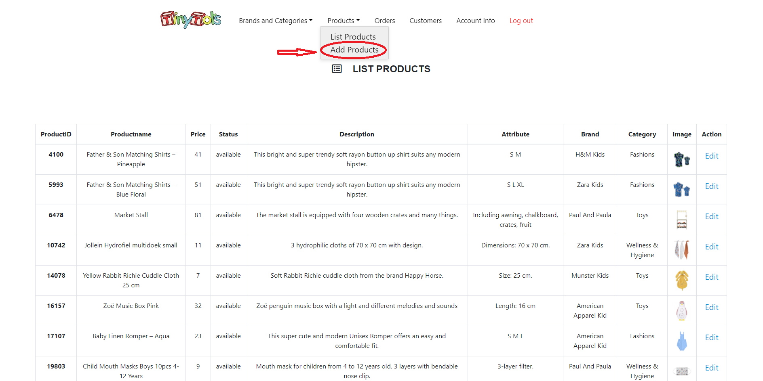

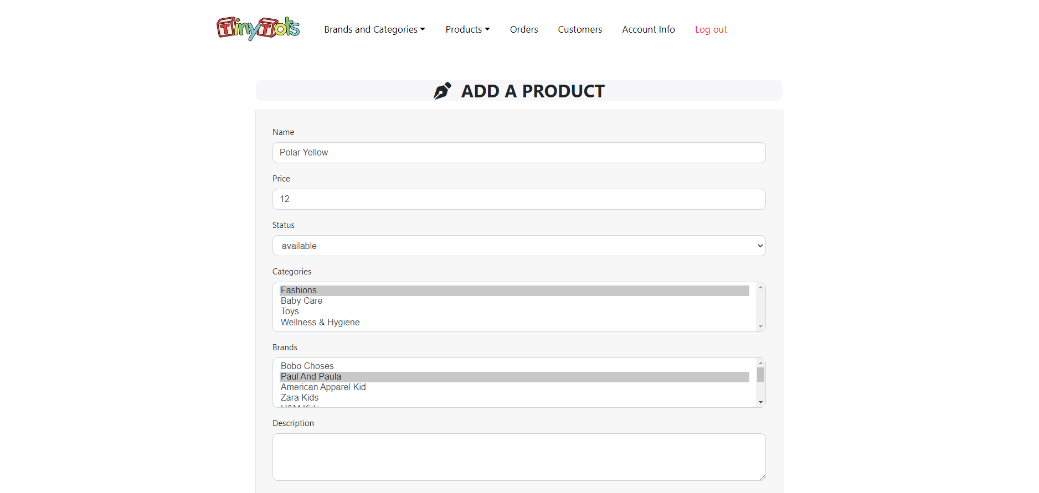

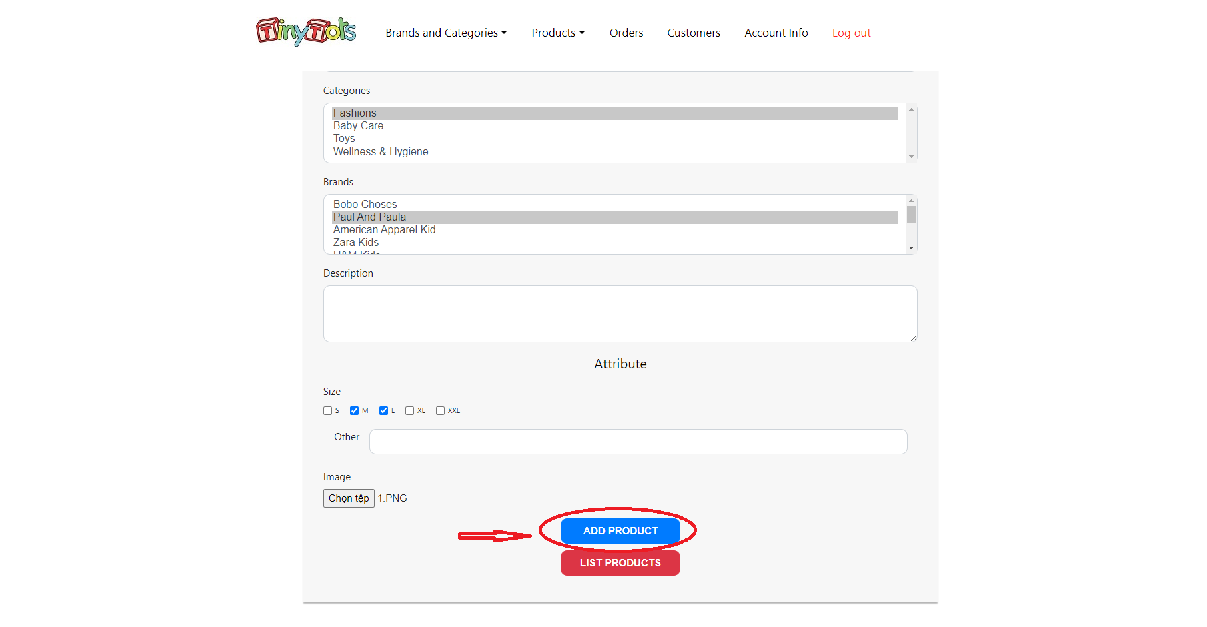

**Edit Products:**

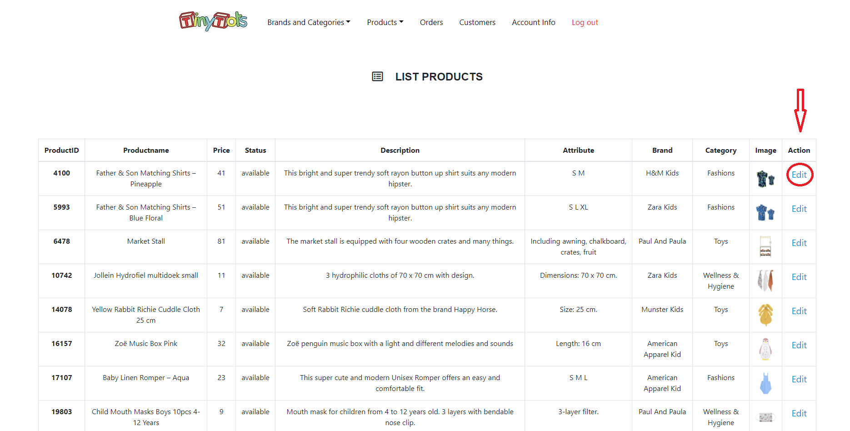

**Delete Products:**

If admin want to delete a product on the product page, admin go to the product edit section, adjust the status to sold out:

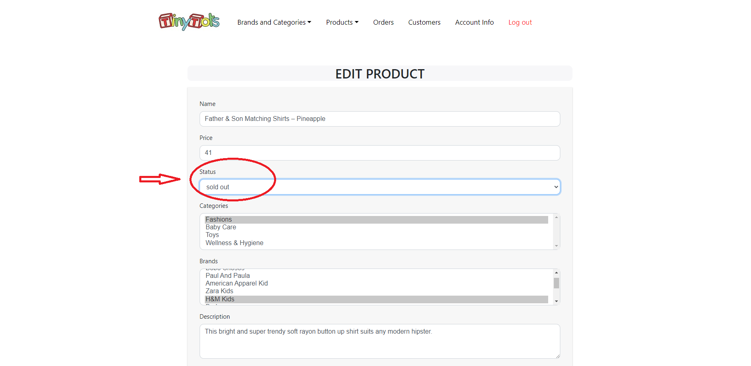

**View and edit customer information:**

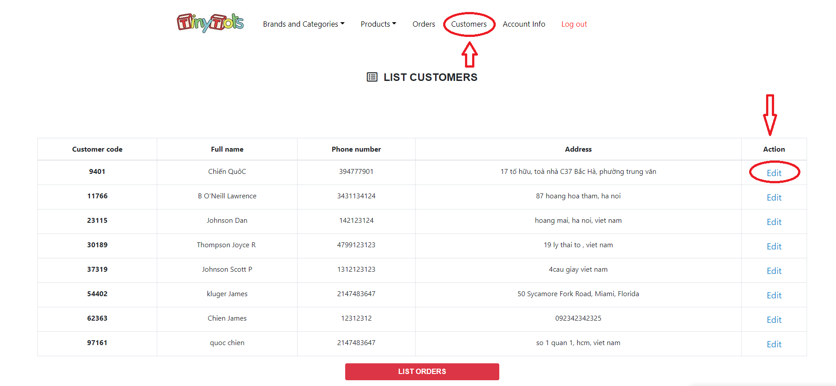

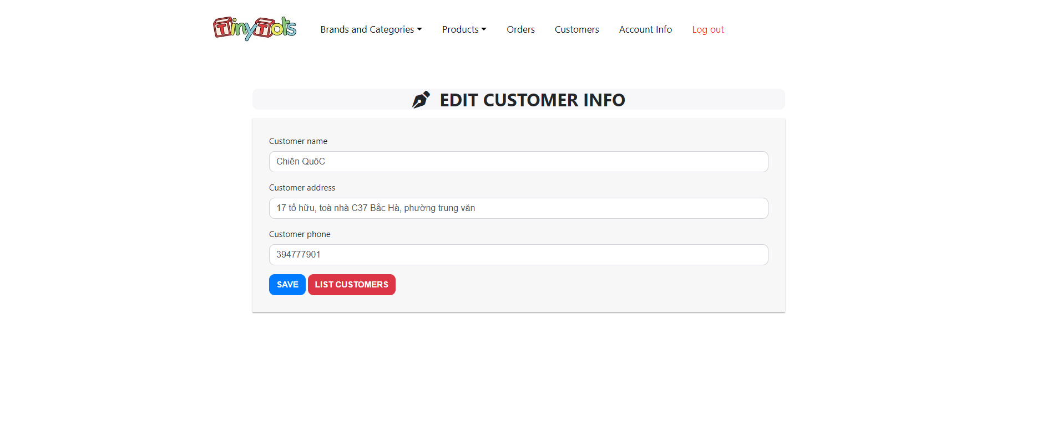

**View Orders:**

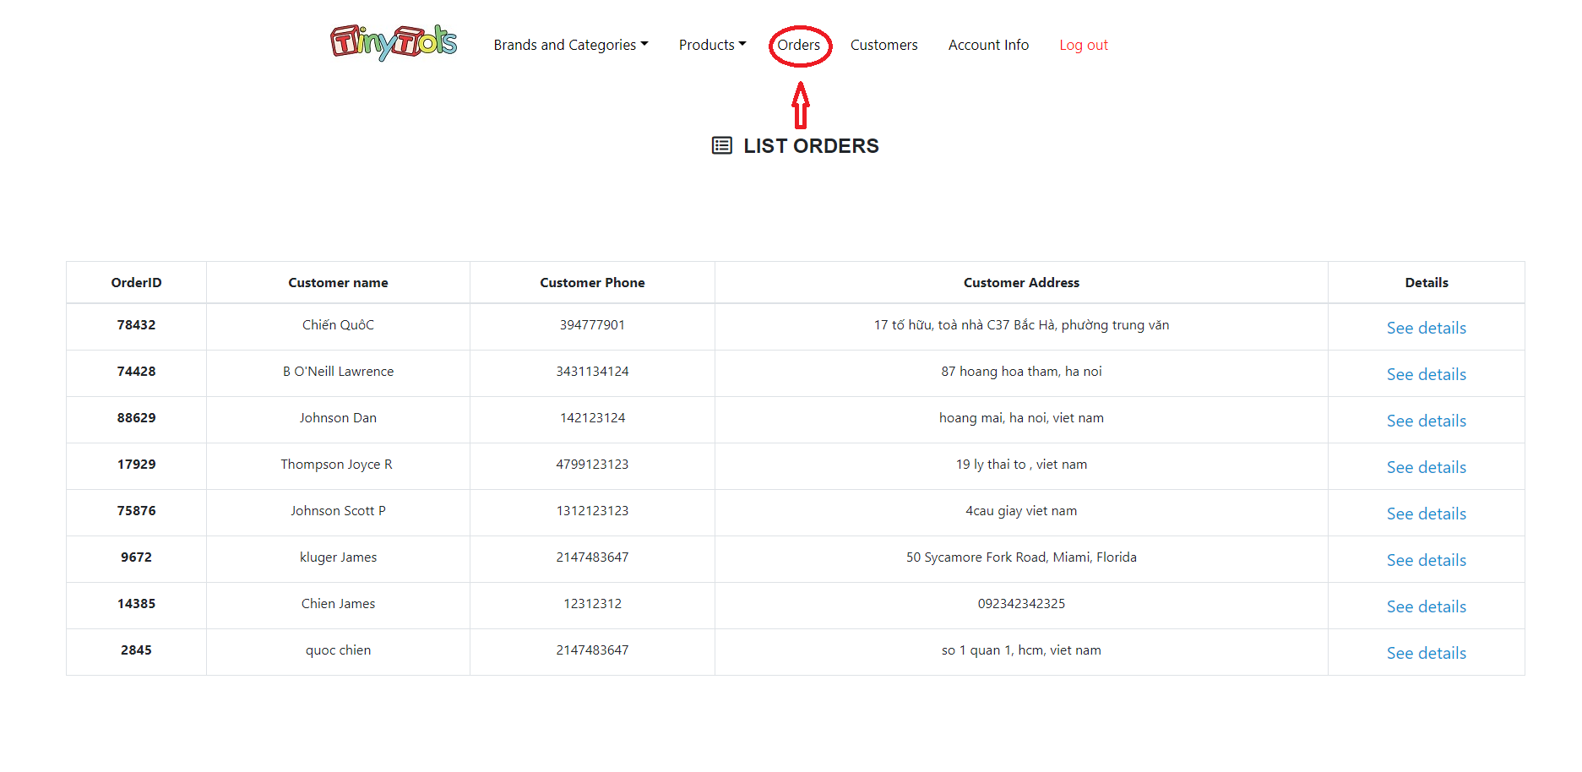

1. Conclusions and Directions of Development

* **Conclude**:
  + advantage:
    - Learn about PHP languages
    - Know more about boostrap, css.
    - More progress in problem analysis
  + shortcoming:
    - add more functions. and improve the interface more beautiful
* **Conclusions and Directions of Development:**
  + Ajax and javascript integration will help the website improve
  + The system should have additional membership functions to develop more online payment features as well as receive promotional information